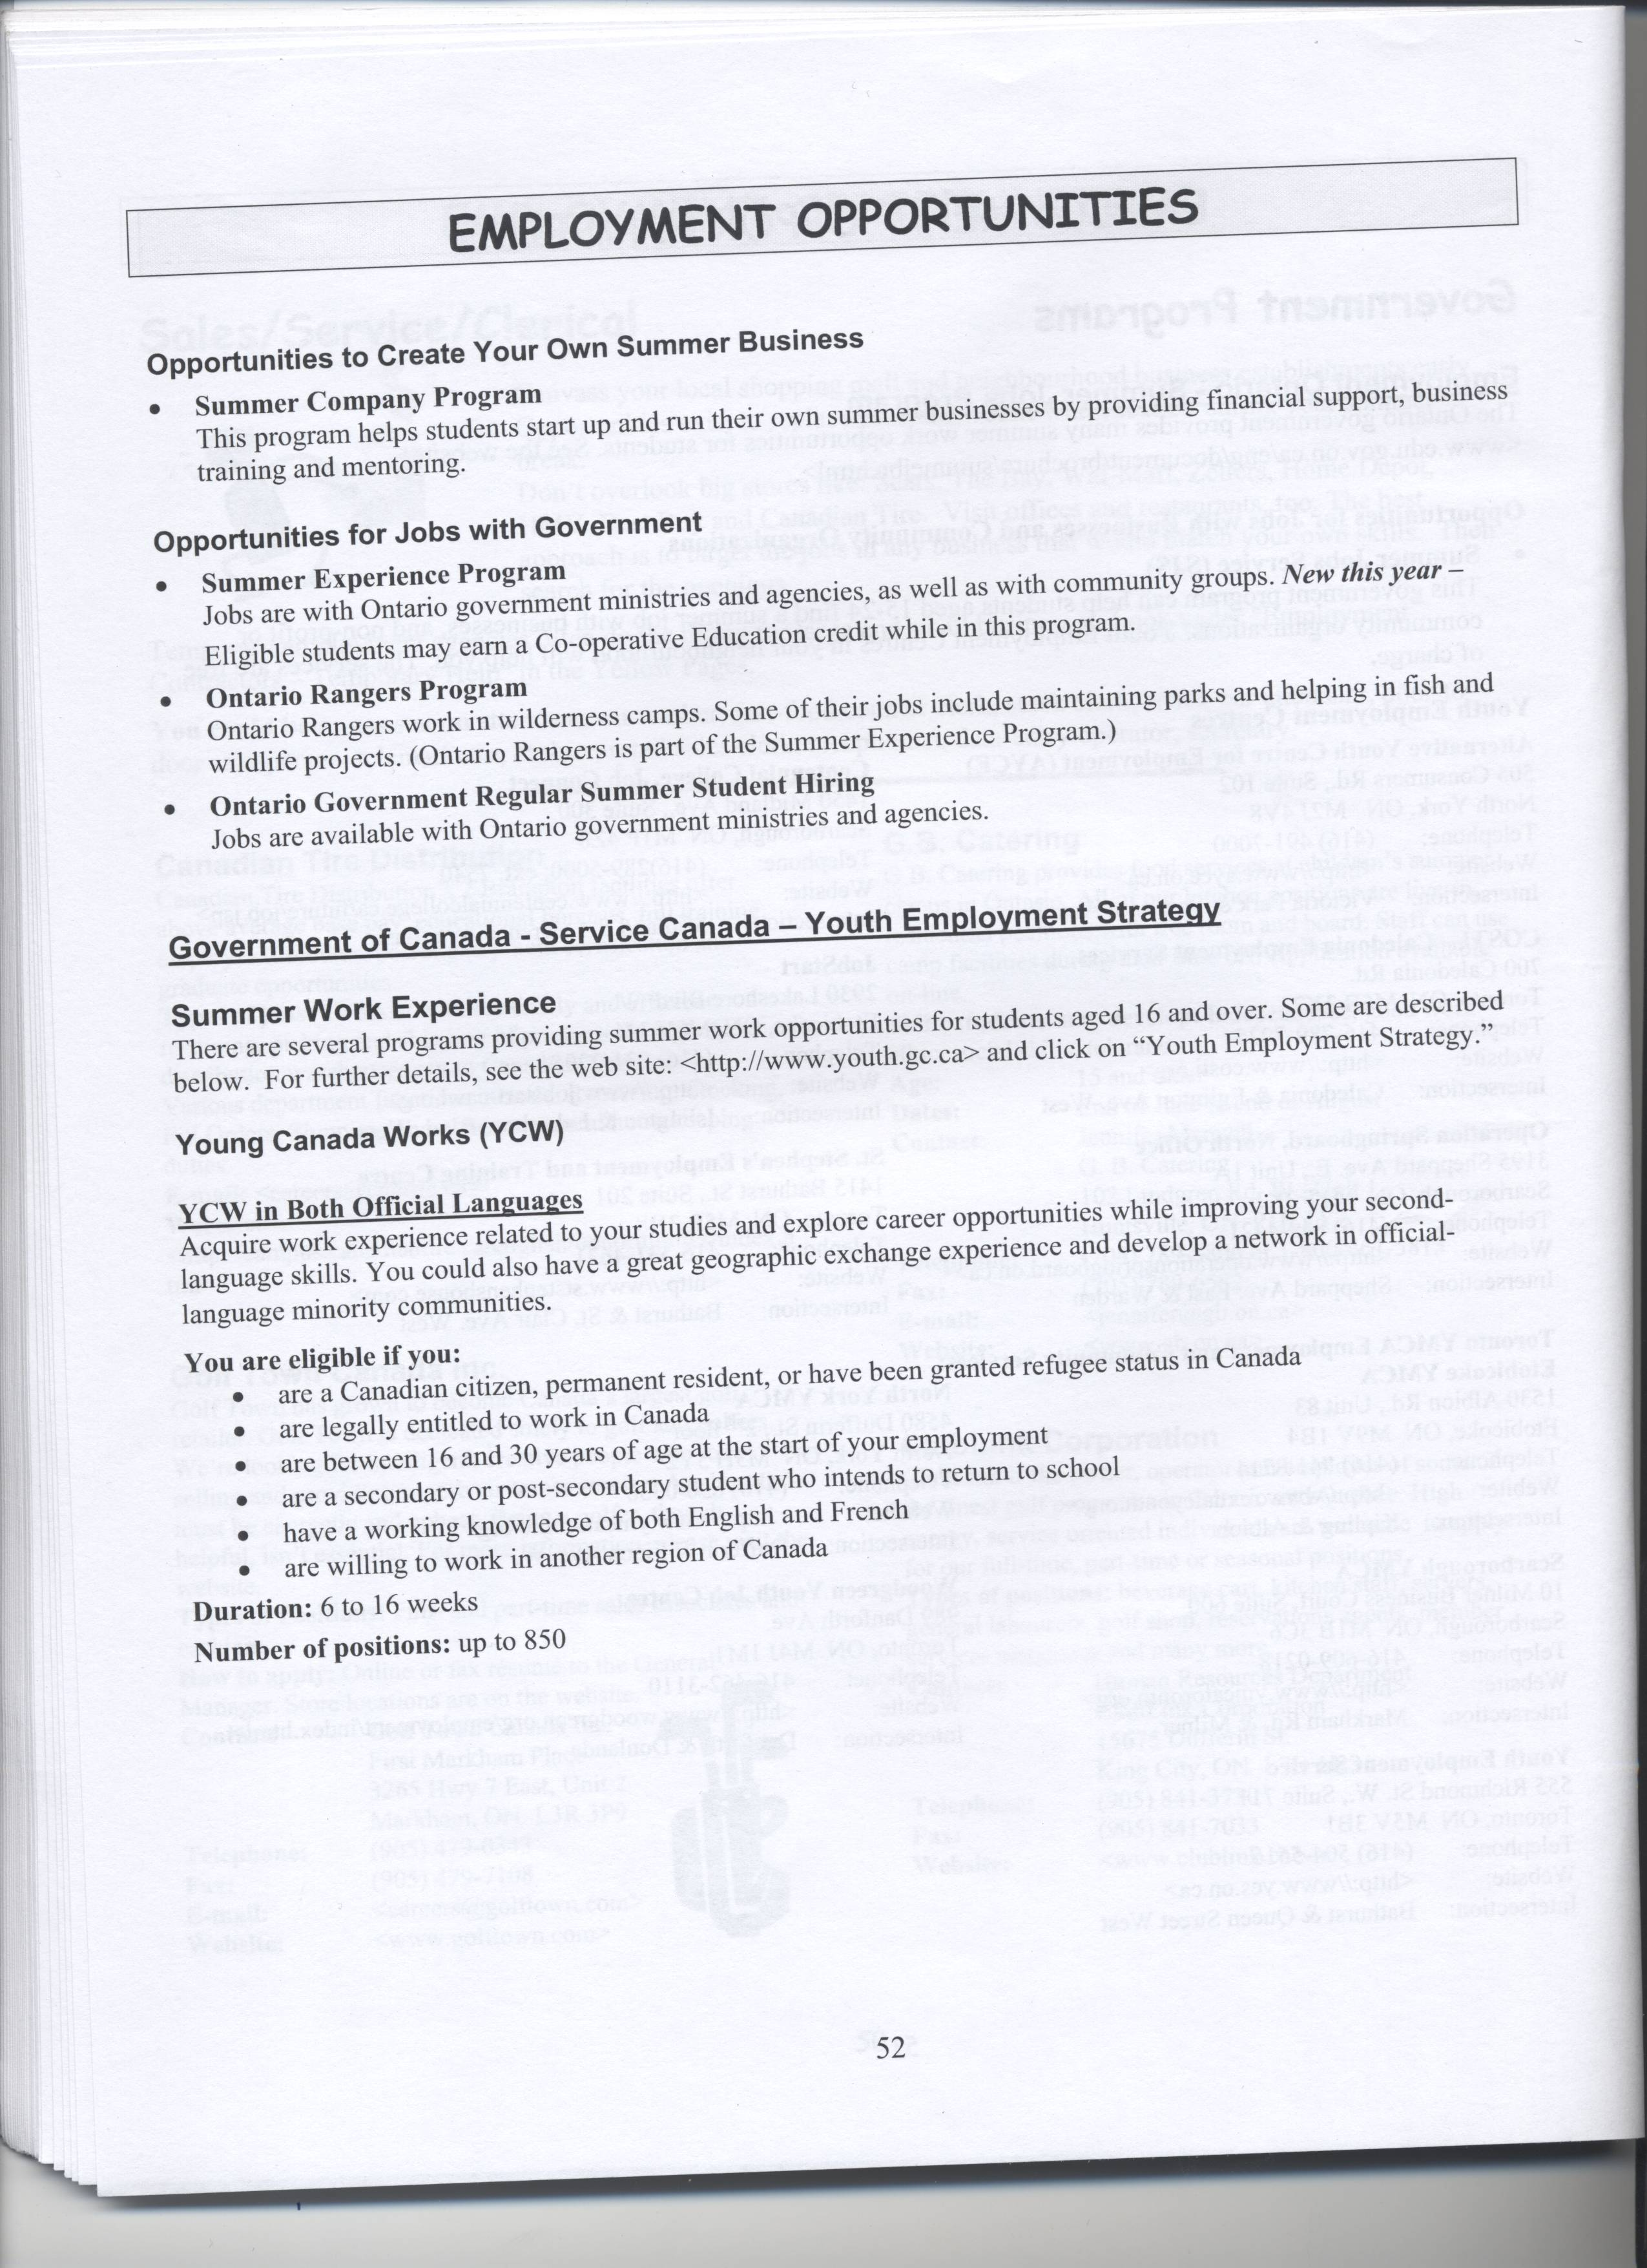
http://www.tcu.gov.on.ca/eng/document/brochure/summejbe.html



